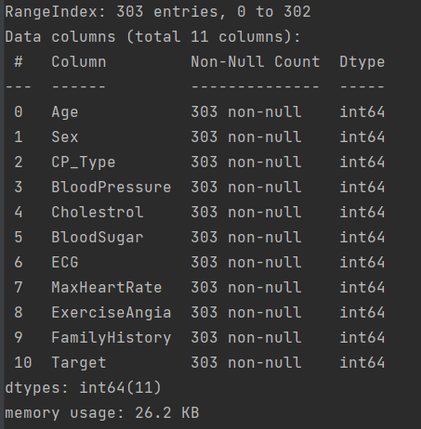

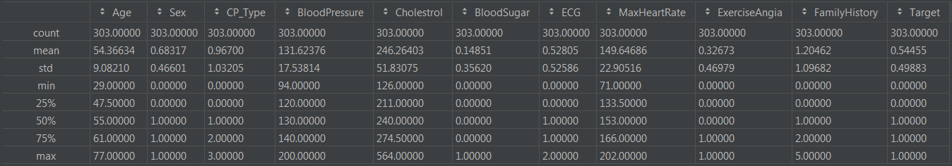

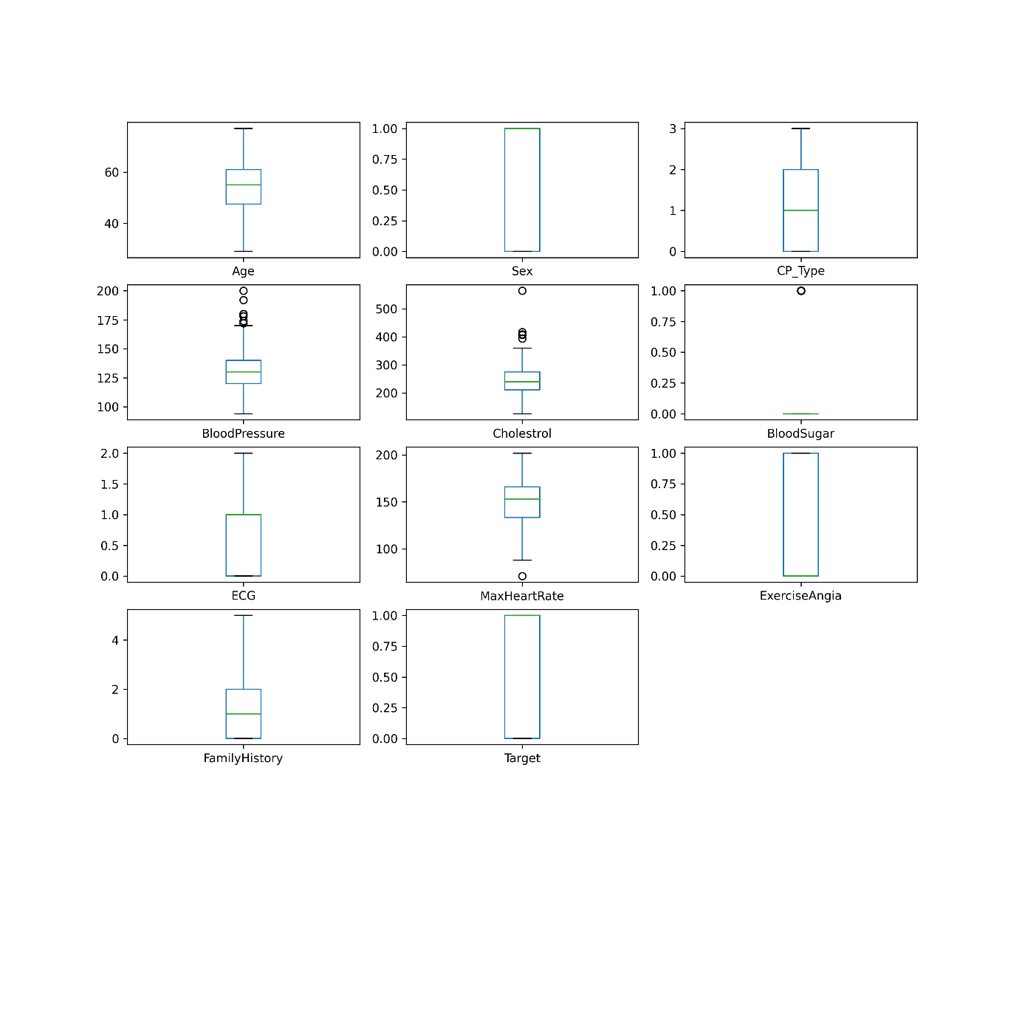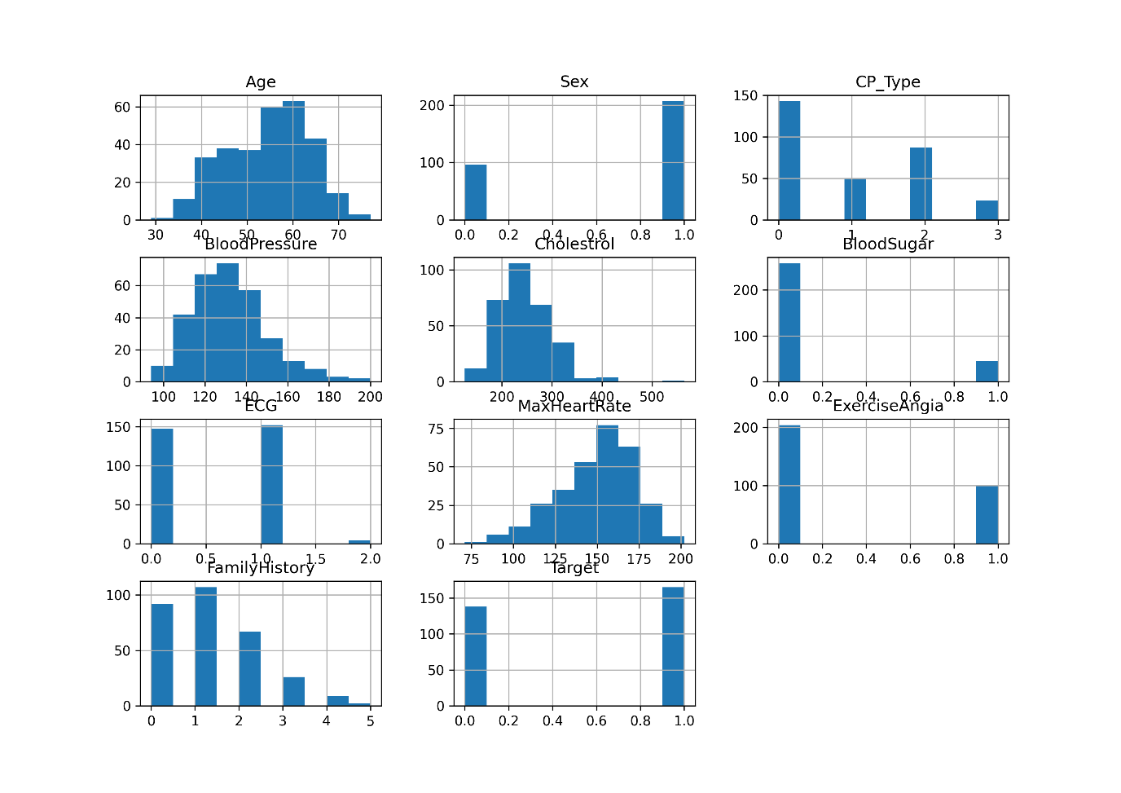

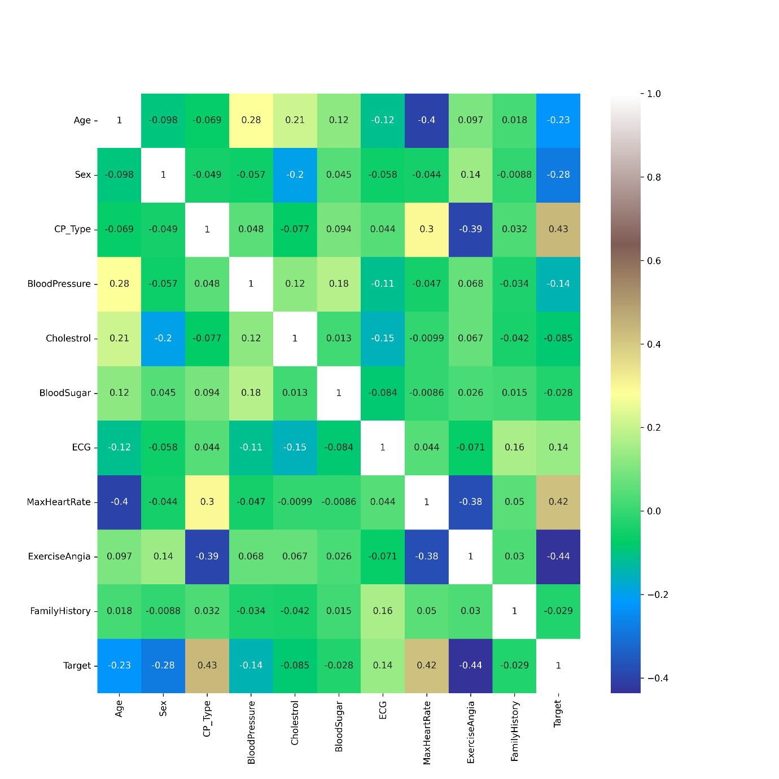

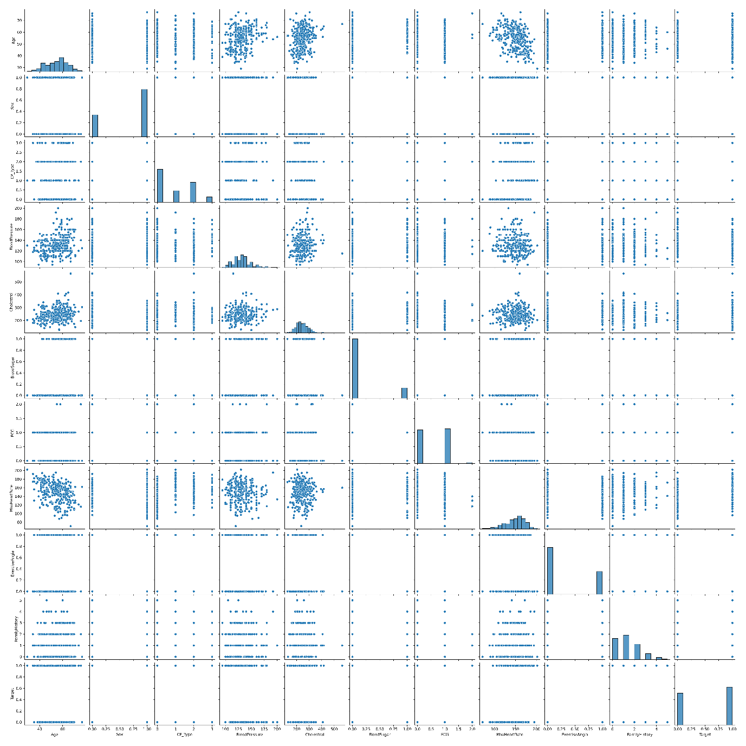

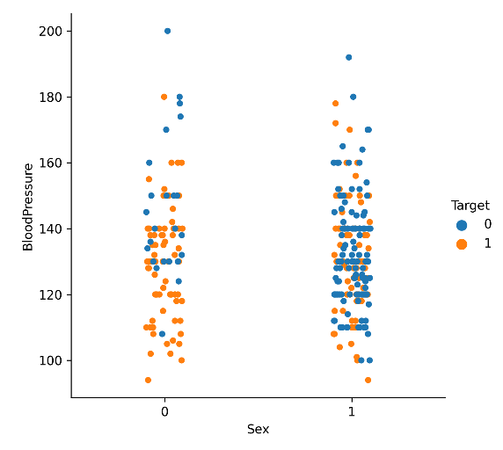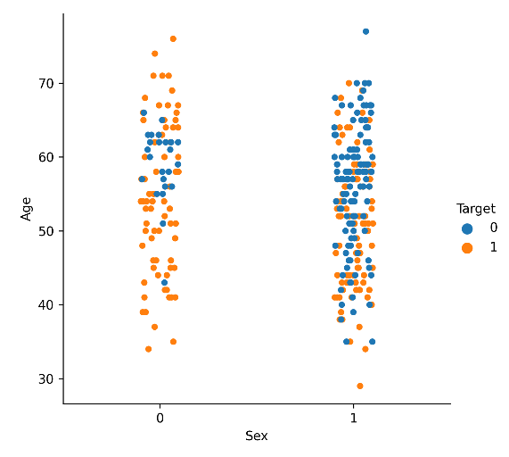

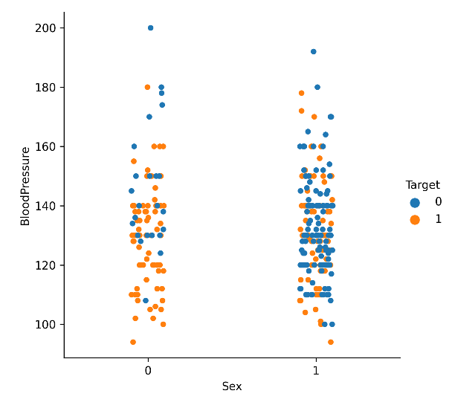

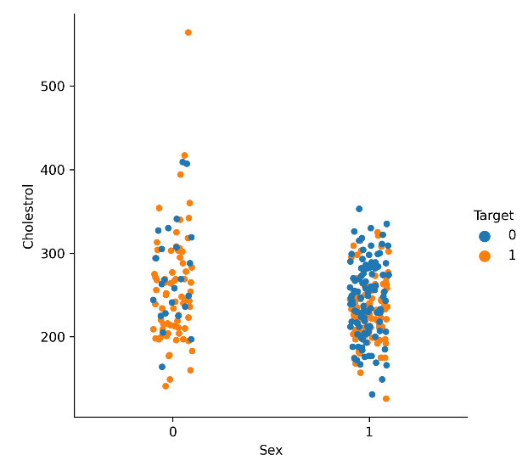

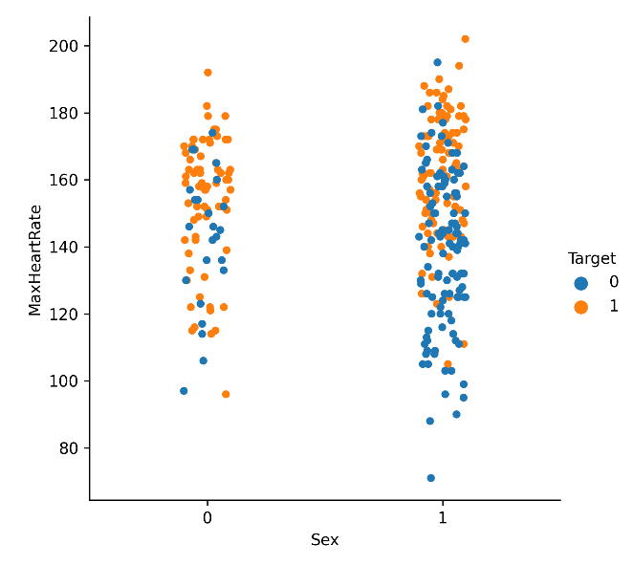

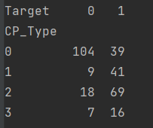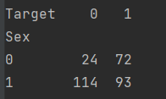

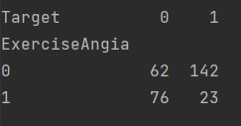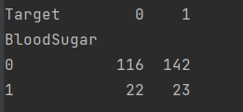

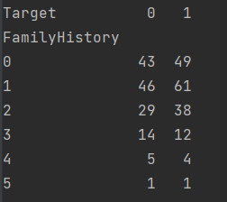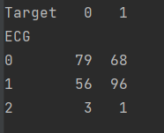

X_train, X_test,Y_train,Y_test = train_test_split(X,Y,test_size=0.15,stratify=Y,random_state=int(i))

11.0 Decision Tree : Train 1.0 Test 0.7608695652173914

11.0 Logistic Regression : Train 0.7898832684824902 Test 0.8260869565217391

21.0 Decision Tree : Train 1.0 Test 0.782608695652174

21.0 Logistic Regression : Train 0.7937743190661478 Test 0.8043478260869565

23.0 Decision Tree : Train 1.0 Test 0.7608695652173914

23.0 Logistic Regression : Train 0.7937743190661478 Test 0.8260869565217391

37.0 Decision Tree : Train 1.0 Test 0.7608695652173914

37.0 Logistic Regression : Train 0.8015564202334631 Test 0.7391304347826086

48.0 Decision Tree : Train 1.0 Test 0.782608695652174

48.0 Logistic Regression : Train 0.7782101167315175 Test 0.8260869565217391

51.0 Decision Tree : Train 1.0 Test 0.8260869565217391

51.0 Logistic Regression : Train 0.8015564202334631 Test 0.8043478260869565

54.0 Decision Tree : Train 1.0 Test 0.8695652173913043

54.0 Logistic Regression : Train 0.7821011673151751 Test 0.8695652173913043

57.0 Decision Tree : Train 1.0 Test 0.782608695652174

57.0 Logistic Regression : Train 0.7859922178988327 Test 0.8260869565217391

73.0 Decision Tree : Train 1.0 Test 0.782608695652174

73.0 Logistic Regression : Train 0.7937743190661478 Test 0.782608695652174